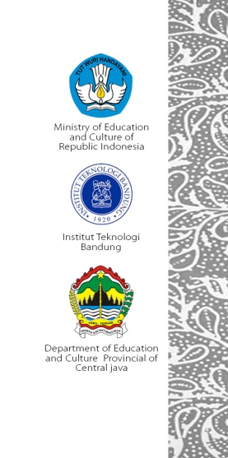
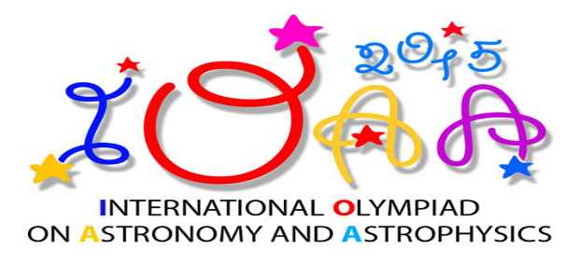

- During observation test using small telescope, you will receive :
- Problem sheet
- Answer sheet
- Additional sheet
- Flashlight

- During naked eye test, you will receive :
- Problem sheet
- Answer sheet
- Additional sheet
- Flashlight

- During observation test using main telescope, you will receive :
- Problem sheet
- Answer sheet
- Additional sheet
- Headlamp
- Clip Board

- During observation test using planetarium (in case of rainy or cloudy), you will receive :
- Problem sheet
- Answer sheet
- Additional sheet
- Flashlight
- Clip Board

